18.88: a) Following Example 18.4, 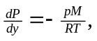 which in this case becomes
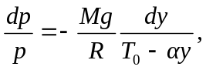
which integrates to
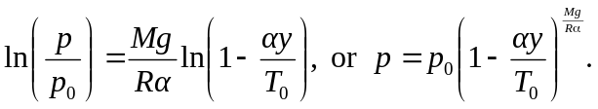
b) Using the first equation above, for sufficiently small 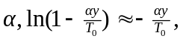 and this gives the expression derived in Example 18.4.

c) 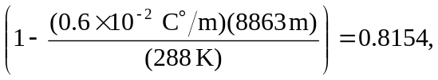
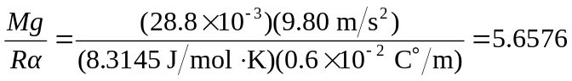
(the extra significant figures are needed in exponents to reduce roundoff error), and 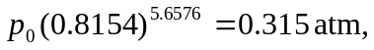 which is 0.95 of the result found in Example 18.4. Note: for calculators without the 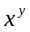 function, the pressure in part (c) must be found from 